**My to do list**

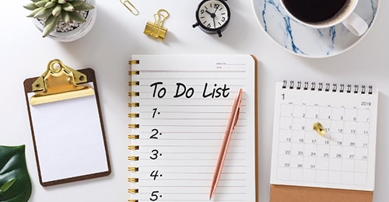

Description app  :

Todo Lists are the lists that we generally use to maintain our day-to-day tasks or list of everything that we have to do, with the most important tasks at the top of the list, and the least important tasks at the bottom. It is helpful in planning our daily schedules. We can add more tasks at any time and delete a task that is completed. The four major tasks that we can perform in a TODO list are :

* *Add tasks*
* *Update tasks*
* *Read tasks*
* *Delete tasks*

*Exemple To Do list is your best ally when you are an entrepreneur*

*Being an entrepreneur means always having a lot of things in mind, with the risk of being overwhelmed by the mass of work or losing sight of the completion of certain tasks. Establishing a “To Do list” is an ideal habit for business leaders:*

*it allows you to clarify your thoughts while establishing a precise program of small actions to accomplish but the aim of my app organized my work and my life and in my app I intend to build tow actors (user, visitor public ) also Having a list of everything you need to do written down makes sure you don't forget anything important. By prioritizing the tasks on the list, you plan the order in which you will do them and you can*